HND Computing:

Software Development

Graded unit 2

H48W35

User Documentation

Brodie Harkins

*Contents Page*

1. Login Screen
2. Admin Screen
3. Coach Screen (Player)
4. Coach Screen (Junior)

*Login Screen*

Upon Logging in the user will be greeted with the login screen. It will present 2 different text fields for you to enter your login details.

For Administrative use login using the Username: Admin & Password: 1.

For Junior Coach login, Use the default Login – Username: MZimmer & Password: 1

For Over 18 Coach, Use the default login – Username: Dav & Password: 1

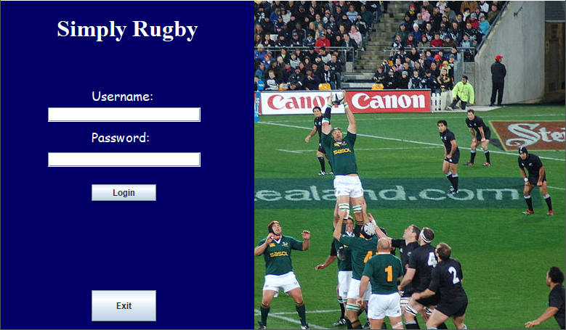You can add your own admin user or Junior/Adult Coach if needed, this will be shown later in the document.

Admin Page

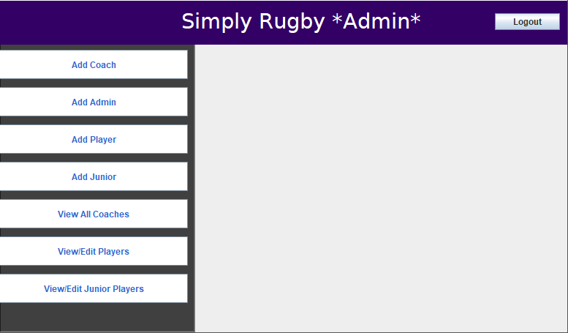Within the admin page you have a list of options to choose from, as seen from the picture below.

Selecting any of the buttons on the right-hand side of the screen will display what you want to do.

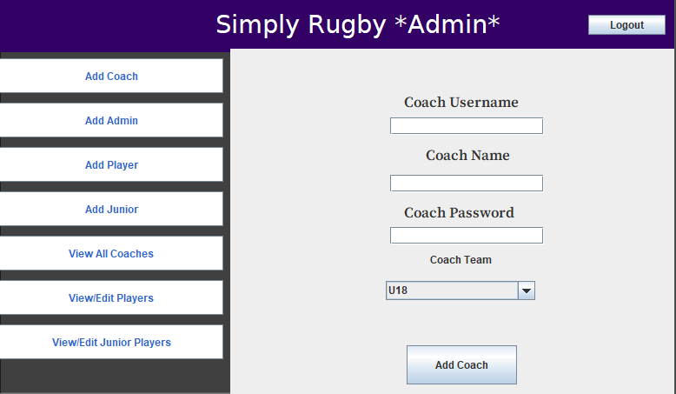Going in order of the buttons, if you’d like to add a coach you will be greeted with 3 different text fields and a combo box in which you can select what type of coach you’d like to add to the system.

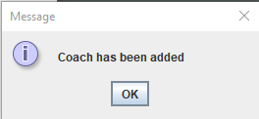Upon adding the coach, you will be shown a confirmation box telling you the addition of the coach is successful.

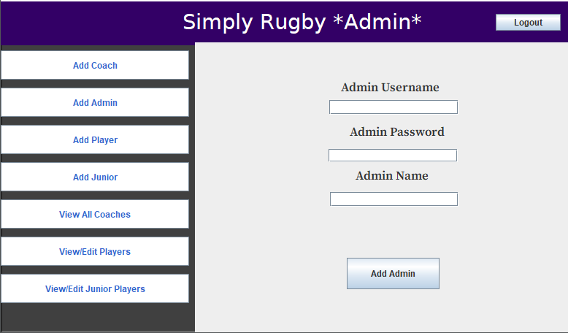If selecting *Add Admin*, you will be greeted with the same layout as adding a coach but instead you’ll be able to add an admin to the system.

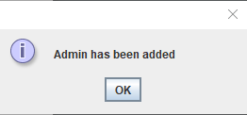Upon completion of adding a new admin. You will know it has been successfully added when this prompt appears.

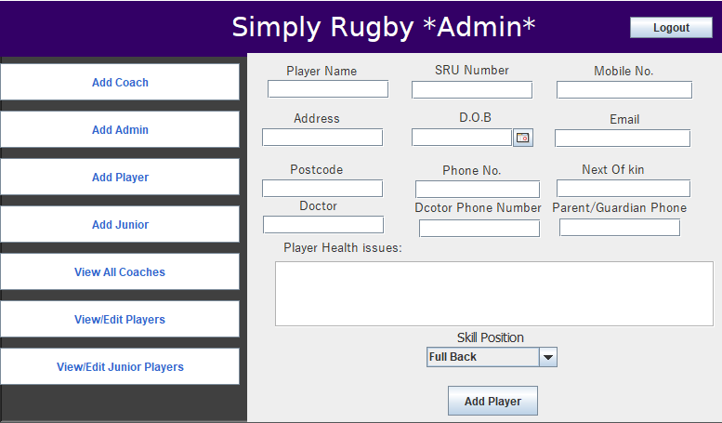If selecting *Add Player,* you will be shown multiple fields which you will be able to populate with player details. This screen will look like this:

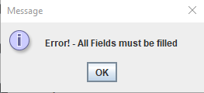Within in this screen you’ll be able to select the player position and use a calendar to input the date of birth of the player. If you do miss any fields, you will be alerted with a prompt stating:

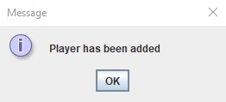Else, if all fields have been correctly filled you will be shown the message

Add Junior Screen

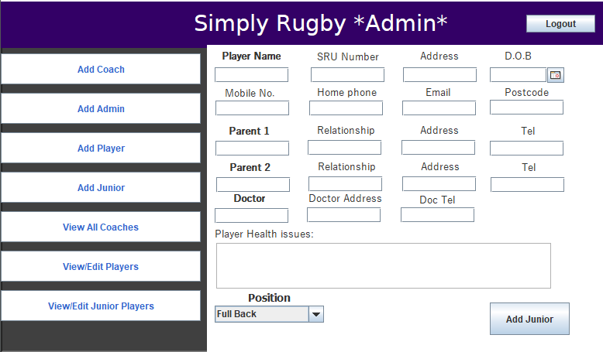Upon selecting this screen, you will be shown a similar layout to when you want to add a player. This screen is shown below.

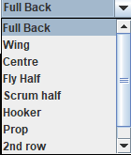As you can see above, you are able to enter the date of birth using the same Calendar as the player and able to enter in their position and health. If you would like to select a position for the junior, select the combo box and all positions will be displayed like this.

You’ll be able to select and once a position has been selected you can add the player to the system.

View/Delete Coaches

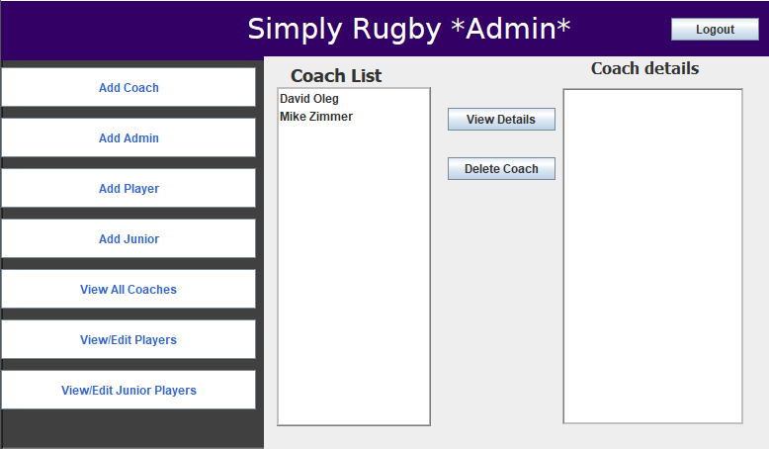If you’d like to view the coaches that you have added to the system, you can select the *View Coaches.* Once selected, it will display the view coaches panel.

As you can see above, you’ll have two options to choose from. If you’d like to view the details of the coach you’ve previously added, select the *View Details* buttons which will display all the details of the selected coach within the text pane on the right-hand side of the screen.

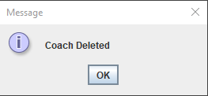If you’d like to remove a coach from the system, you can select *Delete Coach*. Upon deleting a coach, you will be displayed a confirmation box showing:

View/Edit Players

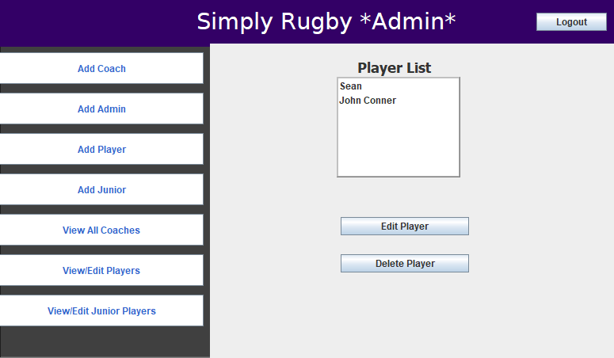By selecting *View/Edit Players,* you will be shown a list of players where you can select a player and edit their details. The main screen will look like this:

Upon selecting a player to edit, you’ll be shown a screen like this:

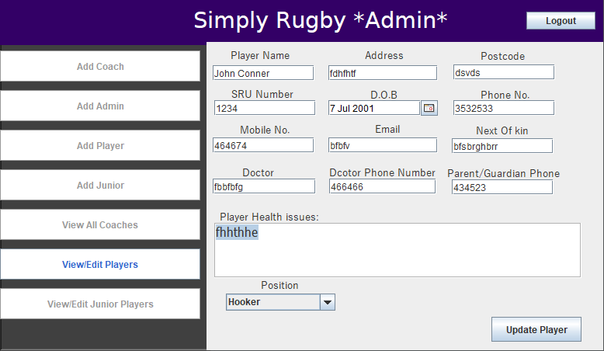If you decide to edit their details, click save and their details will be saved.

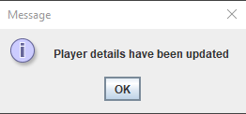A message box will be displayed when *Update Player* is selected:

View/Edit Juniors

If you’d like to view and edit junior player details, you can select *View/Edit Juniors.* This will display the panel where you can edit and remove juniors. This screen will look like this:

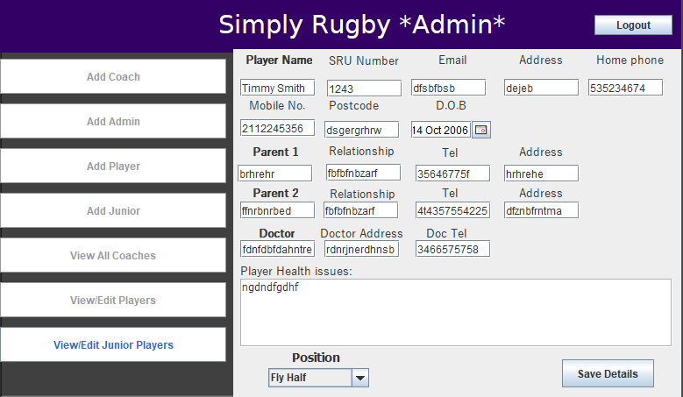

Coach Home Page (O18)

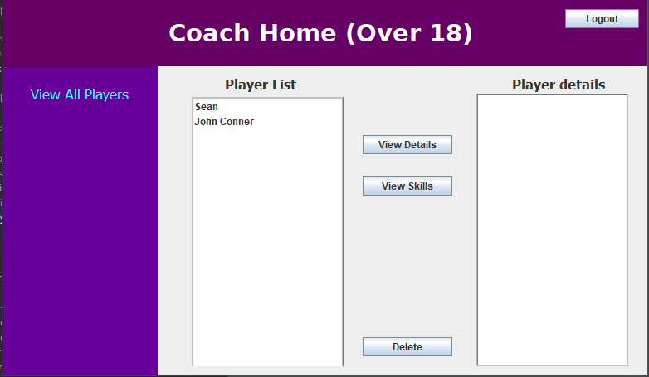If logging as the Over 18 coach, you will be taken to the Coach Over 18 squad page. This whereas the coach you can view, edit, and remove juniors from the team. This page will look like this:

If you’d like to view the player skills, select the player in the list. As an example, we’ll select sean to view his skills. This will look like this:

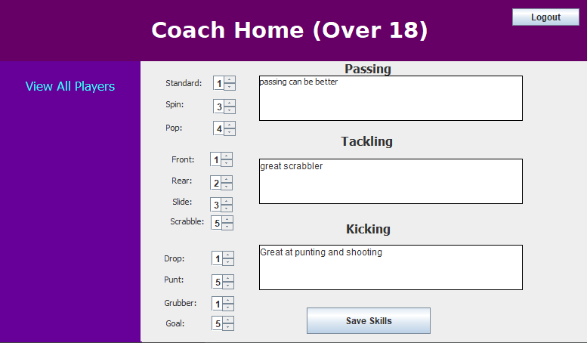As you can above, you can edit Sean skills. Using the spinners on the left-hand side which will indicate how good the player is at a particular skill. 1 being the worst & 5 being the best. Also if you’d like to add notes to a skill, you can enter information regarding how good or what work is needed to improve that particular skill.

Coach Home page (Junior)

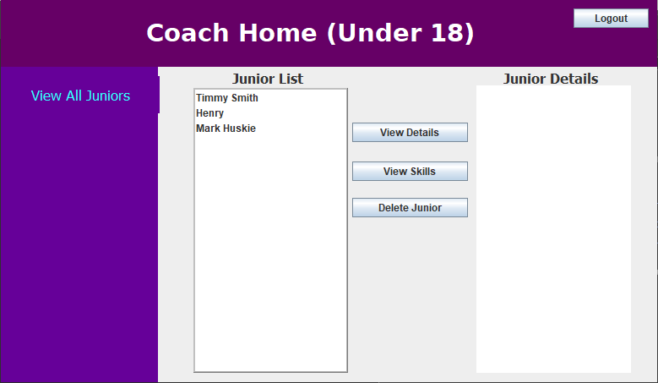Upon logging in as the Junior Coach, you will be taken to the junior coach home page. It will look like this:

In this page, you’ll have the same functionality as the O18 Coach. You’ll be able to view & edit junior skills and remove juniors from the system.

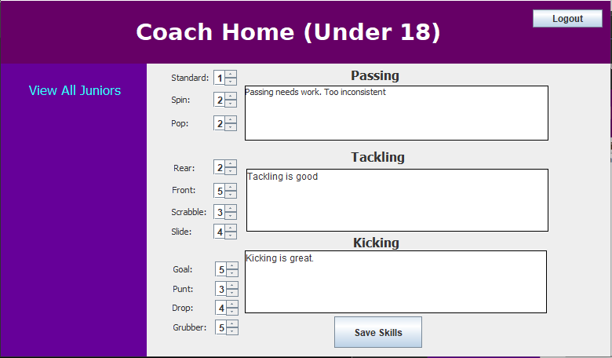Again, to view their skills you can select *View Skills* after selecting the junior you’d like to view/edit their skills. The screen will look like this: